**AdventureWorks2014 - Query**

**Database**: AdventureWorks2014 – ERD Model

**Query 1**

* What are the total sales, total cost & number of orders by product category?

select pc.Name as Category, sum(od.LineTotal) as 'Total Sales', sum(p.StandardCost * od.OrderQty)

as 'Total Cost', sum(od.OrderQty) as 'Number of orders'

from Sales.SalesOrderHeader as oh

join Sales.SalesOrderDetail as od on oh.SalesOrderID = od.SalesOrderID

join Sales.SpecialOfferProduct as sop on sop.ProductID = od.ProductID

join Production.Product as p on od.ProductID = p.ProductID

join Production.ProductSubcategory as ps on p.ProductSubcategoryID = ps.ProductSubcategoryID

join Production.ProductCategory as pc on ps.ProductCategoryID = pc.ProductCategoryID

group by pc.Name;

TOTAL ROWS:-4 rows

TABLE USED:- SalesOrderHeader, SalesOrderDetail, SpecialOfferProduct, Product, ProductSubcategory, ProductCategory

|  |  |
| --- | --- |
| INPUT COLUMNS | OUTPUT COLUMNS |
| pc.Name | pc.Name |
| od.LineTotal | sum(od.LineTotal) as 'Total Sales' |
| p.StandardCost | sum(p.StandardCost * od.OrderQty) as 'Total Cost' |
| od.OrderQty |  |
| od.OrderQty | sum(od.OrderQty) as 'Number of orders' |

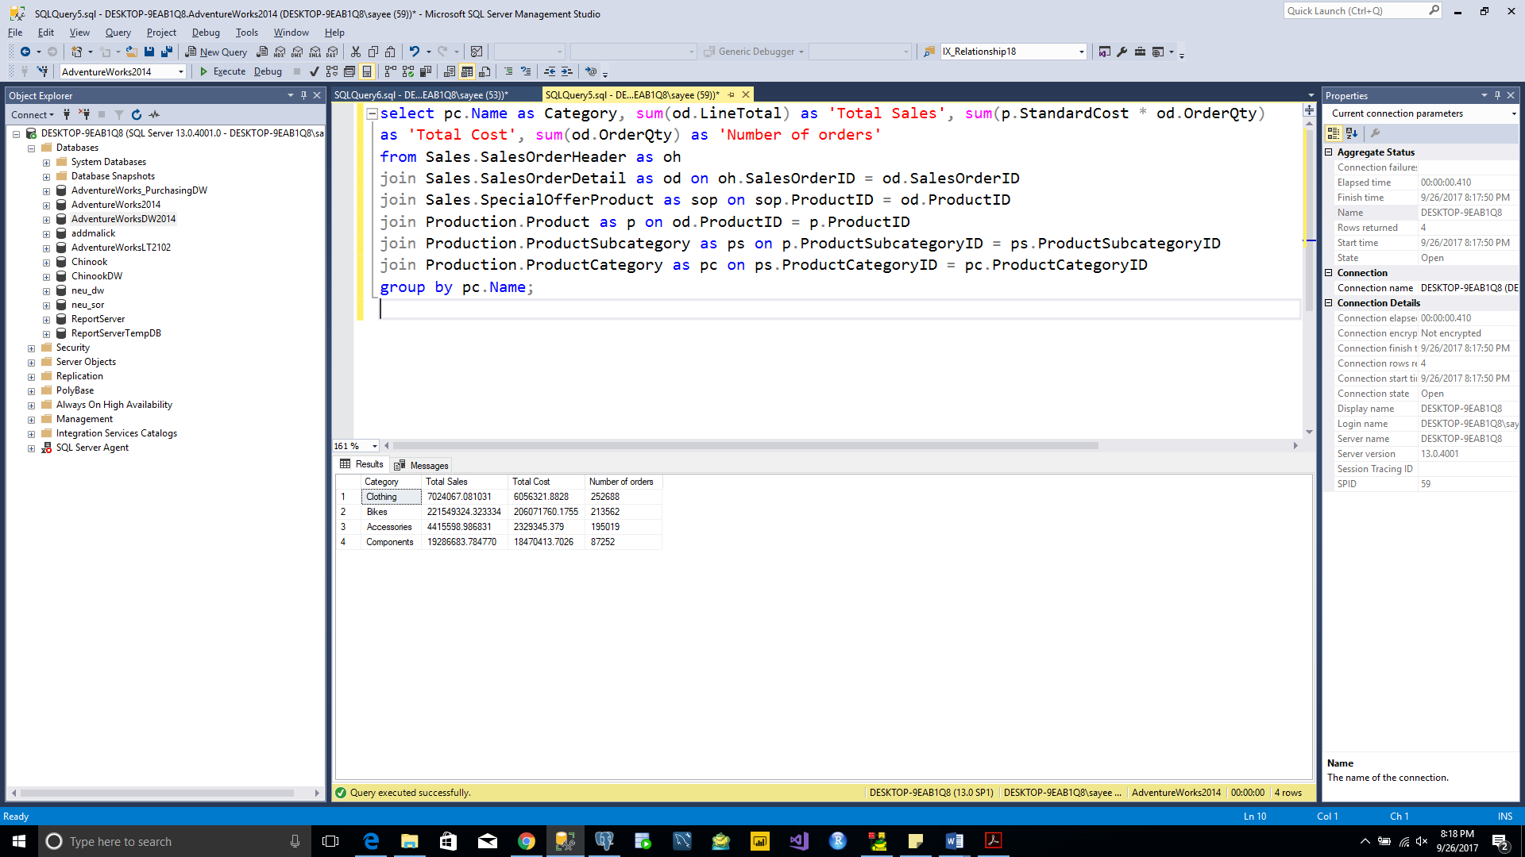

**Query 2**

* What are the total sales, total cost & number of orders by sales territory?

select st.Name as Product, sum(od.LineTotal) as 'Total Sales', sum(p.StandardCost * od.OrderQty)

as 'Total Cost', sum(od.OrderQty) as 'Number of orders'

from Sales.SalesOrderHeader as oh

join Sales.SalesOrderDetail as od on oh.SalesOrderID = od.SalesOrderID

join Sales.SpecialOfferProduct as sop on sop.ProductID = od.ProductID

join Production.Product as p on od.ProductID = p.ProductID

join Sales.SalesTerritory as st on oh.TerritoryID = st.TerritoryID

group by st.Name;

TOTAL ROWS:-10 rows

TABLE USED:- SalesOrderHeader, SalesOrderDetail, SpecialOfferProduct, Product, SalesTerritory

|  |  |
| --- | --- |
| INPUT COLUMNS | OUTPUT COLUMNS |
| st.Name | st.Name |
| od.LineTotal | sum(od.LineTotal) as 'Total Sales' |
| p.StandardCost | sum(p.StandardCost * od.OrderQty) as 'Total Cost' |
| od.OrderQty |  |
| od.OrderQty | sum(od.OrderQty) as 'Number of orders' |

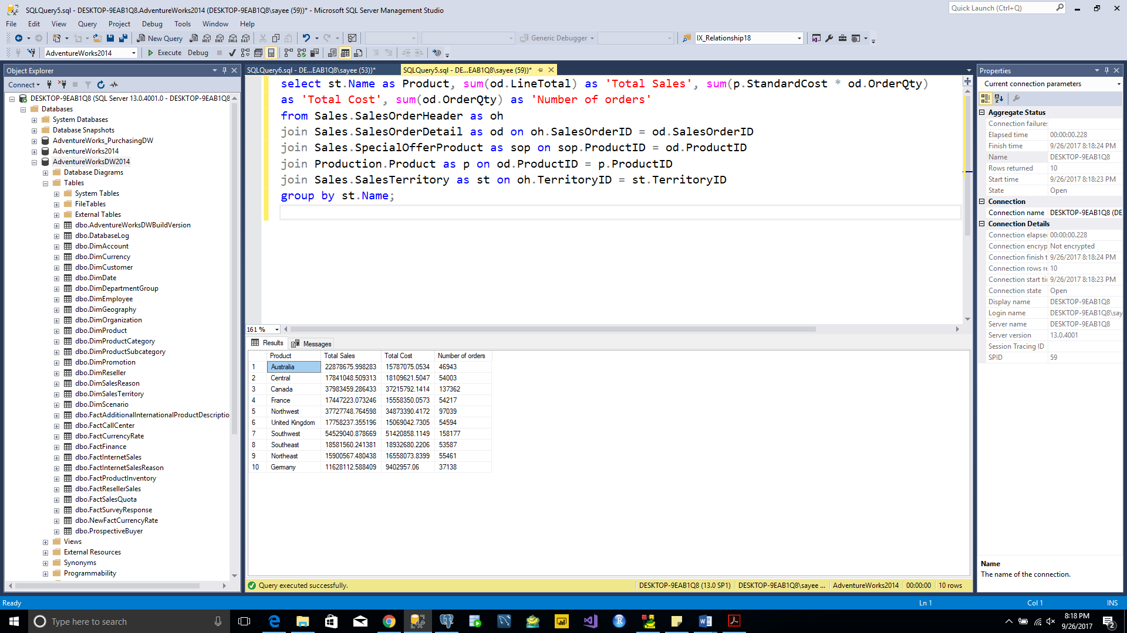

**Query 3**

* What are the total sales by month/year?

Select format(DueDate,'MMMM/yyyy', 'en-us') as MonthYearSales, sum(sod.LineTotal) as TotalSales from sales.SalesOrderHeader as soh

join Sales.SalesOrderDetail as sod on soh.SalesOrderID = sod.SalesOrderID

group by format(DueDate,'MMMM/yyyy', 'en-us')

TOTAL ROWS:-38 rows

TABLE USED:- SalesOrderHeader, SalesOrderDetail

|  |  |
| --- | --- |
| INPUT COLUMNS | OUTPUT COLUMNS |
| DueDate | format(DueDate,'MMMM/yyyy', 'en-us') as MonthYearSales |
| sod.LineTotal | sum(sod.LineTotal) as 'Total Sales' |

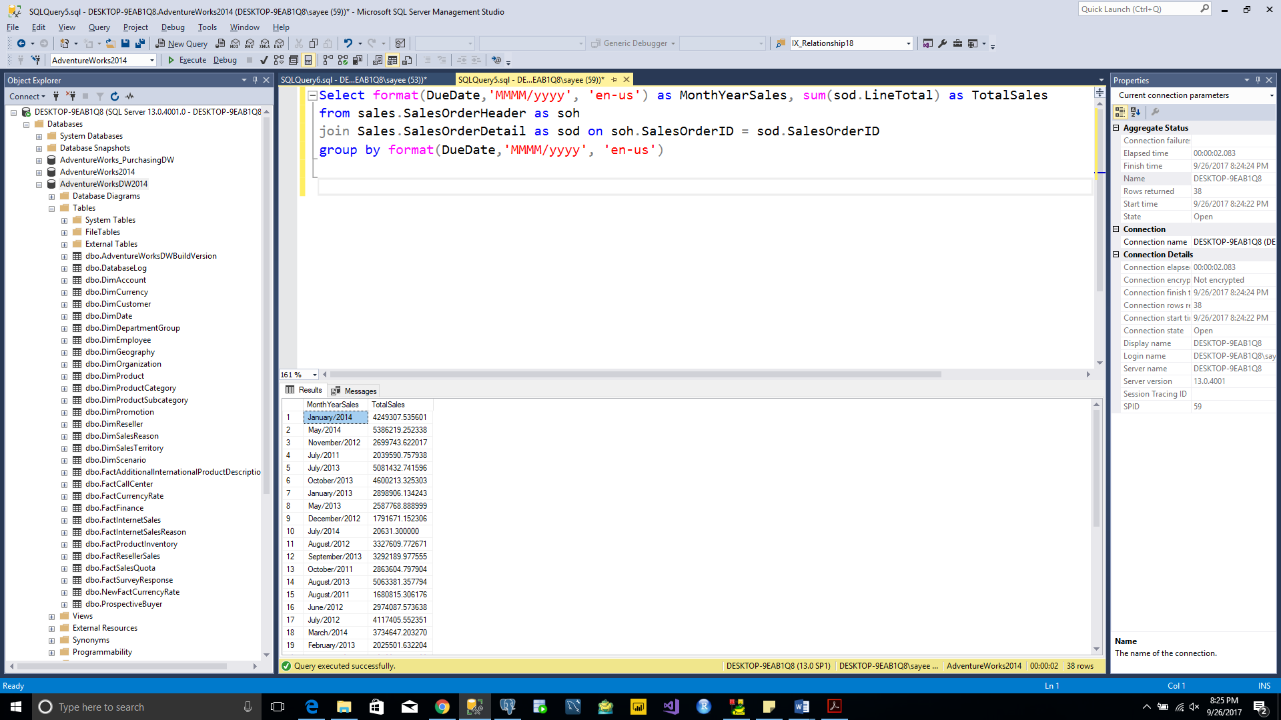

**Query 4**

* What are the reseller sales & product costs by product Hierarchy?

select pc.Name as ProductCategory, ps.Name as ProductSubCategory, p.Name as ProductName,

sum(od.LineTotal) as 'Total Sales', sum(p.StandardCost * od.OrderQty) as 'Total Cost'

from Sales.SalesOrderHeader as oh

join Sales.SalesOrderDetail as od on oh.SalesOrderID = od.SalesOrderID

join Sales.SpecialOfferProduct as sop on sop.ProductID = od.ProductID

join Production.Product as p on sop.ProductID = p.ProductID

join Production.ProductSubcategory as ps on p.ProductSubcategoryID = ps.ProductSubcategoryID

join Production.ProductCategory as pc on ps.ProductCategoryID = pc.ProductCategoryID

join Sales.Customer as cus on oh.CustomerID = cus.CustomerID

join Sales.Store as sto on cus.StoreID = sto.BusinessEntityID

group by pc.Name, ps.Name, p.Name;

TOTAL ROWS:-250 rows

TABLE USED:- SalesOrderHeader, SalesOrderDetail, SpecialOfferProduct, Product, ProductSubcategory, ProductCategory, Customer, Store

|  |  |
| --- | --- |
| INPUT COLUMNS | OUTPUT COLUMNS |
| pc.Name | pc.Name |
| ps.Name | ps.Name |
| p.Name | p.Name |
| od.LineTotal | sum(od.LineTotal) as 'Total Sales' |
| p.StandardCost | sum(p.StandardCost * od.OrderQty) as 'Total Cost' |
| od.OrderQty |  |

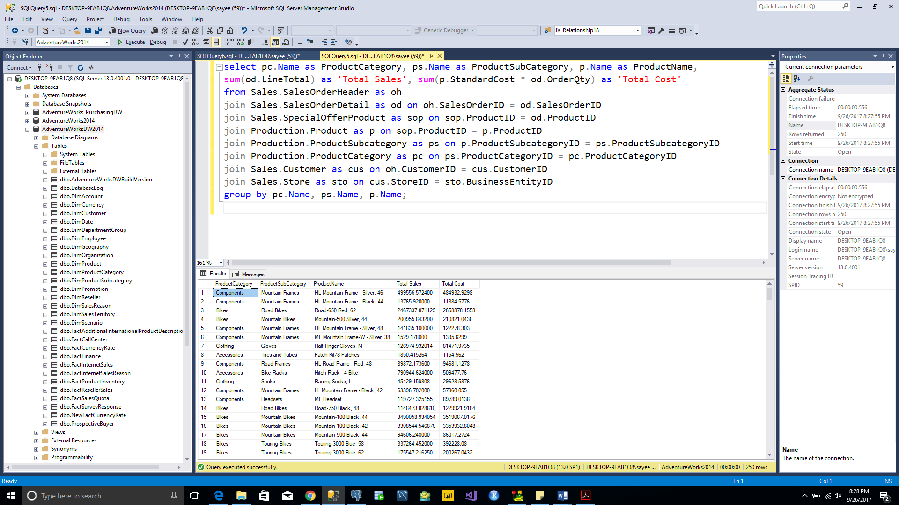

**Query 5**

* What are the internet sales & product costs by geo hierarchy?

select cr.Name as Country, stp.Name as State, ad.City as City,

sum(od.LineTotal) as 'Total Sales', sum(p.StandardCost * od.OrderQty) as 'Total Cost'

from Sales.SalesOrderHeader as oh

join Sales.SalesOrderDetail as od on oh.SalesOrderID = od.SalesOrderID

join Sales.SpecialOfferProduct as sop on sop.ProductID = od.ProductID

join Production.Product as p on sop.ProductID = p.ProductID

join Production.ProductSubcategory as ps on p.ProductSubcategoryID = ps.ProductSubcategoryID

join Production.ProductCategory as pc on ps.ProductCategoryID = pc.ProductCategoryID

join Sales.Customer as cus on oh.CustomerID = cus.CustomerID

join Person.Person as per on cus.PersonID = per.BusinessEntityID

join Person.Address as ad on oh.BillToAddressID = ad.AddressID

join Person.StateProvince as stp on ad.StateProvinceID = stp.StateProvinceID

join Person.CountryRegion as cr on stp.CountryRegionCode = cr.CountryRegionCode

group by cr.Name, stp.Name, ad.City;

TOTAL ROWS:-558 rows

TABLE USED:- SalesOrderHeader, SalesOrderDetail, SpecialOfferProduct, Product, ProductSubcategory, ProductCategory, Customer, Person, Address, StateProvince

|  |  |
| --- | --- |
| INPUT COLUMNS | OUTPUT COLUMNS |
| cr.Name | cr.Name |
| stp.Name | stp.Name |
| ad.City | ad.City |
| od.LineTotal | sum(od.LineTotal) as 'Total Sales' |
| p.StandardCost | sum(p.StandardCost * od.OrderQty) as 'Total Cost' |
| od.OrderQty |  |

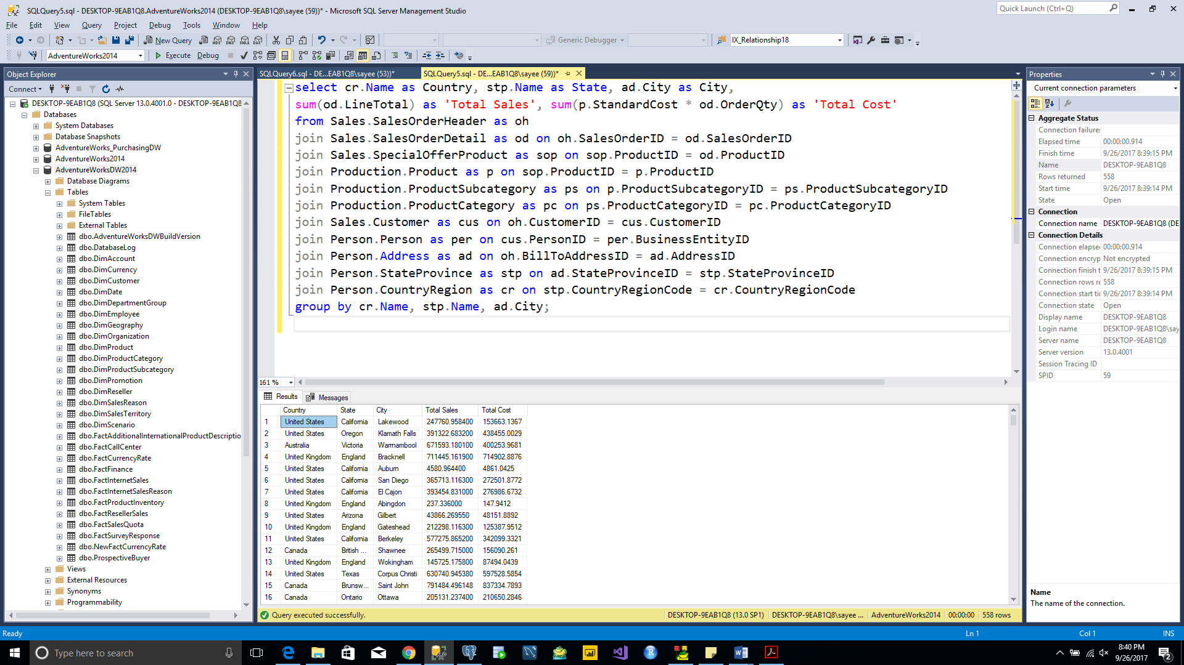

**Query 6**

* What are the ranked sales by product subcategory (largest to smallest)?

select ps.Name as ProductSubCategory,

sum(od.LineTotal) as 'Total Sales',

DENSE_RANK() OVER (ORDER BY sum(od.LineTotal) DESC) AS Ranking

from Sales.SalesOrderHeader as oh

join Sales.SalesOrderDetail as od on oh.SalesOrderID = od.SalesOrderID

join Sales.SpecialOfferProduct as sop on sop.ProductID = od.ProductID

join Production.Product as p on sop.ProductID = p.ProductID

join Production.ProductSubcategory as ps on p.ProductSubcategoryID = ps.ProductSubcategoryID

group by ps.Name;

TOTAL ROWS:-35 rows

TABLE USED:- SalesOrderHeader, SalesOrderDetail, SpecialOfferProduct, Product, ProductSubcategory

|  |  |
| --- | --- |
| INPUT COLUMNS | OUTPUT COLUMNS |
| ps.Name | ps.Name |
| od.LineTotal | sum(od.LineTotal) as 'Total Sales' |
| od.LineTotal | DENSE_RANK() OVER (ORDER BY sum(od.LineTotal) DESC) AS Ranking |

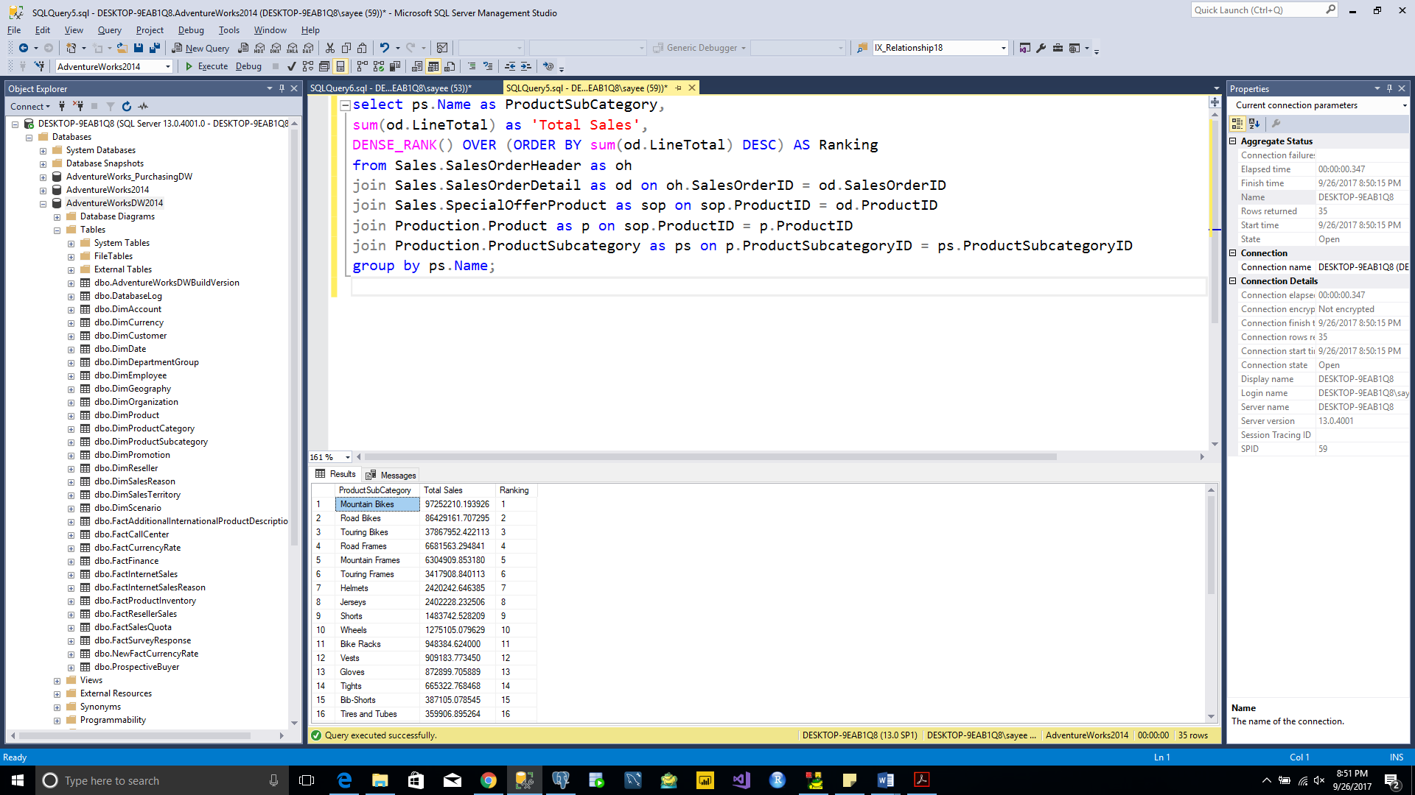

**Query 7**

* What are the top ten resellers by profit?

select Top 10 sto.Name as ResellerName,

(sum(od.LineTotal) - sum(p.StandardCost * od.OrderQty)) as Profit,

DENSE_RANK() OVER (ORDER BY (sum(od.LineTotal) - sum(p.StandardCost * od.OrderQty)) DESC) AS Ranking

from Sales.SalesOrderHeader as oh

join Sales.SalesOrderDetail as od on oh.SalesOrderID = od.SalesOrderID

join Sales.Customer as cus on oh.CustomerID = cus.CustomerID

join Sales.Store as sto on cus.StoreID = sto.BusinessEntityID

join Sales.SpecialOfferProduct as sop on sop.ProductID = od.ProductID

join Production.Product as p on od.ProductID = p.ProductID

group by sto.Name;

TOTAL ROWS:-10 rows

TABLE USED:- SalesOrderHeader, SalesOrderDetail, SpecialOfferProduct, Product, Customer, Store

|  |  |
| --- | --- |
| INPUT COLUMNS | OUTPUT COLUMNS |
| sto.Name | cr.Name |
| od.LineTotal | (sum(od.LineTotal) - sum(p.StandardCost * od.OrderQty)) as Profit, |
| p.StandardCost |  |
| od.OrderQty |  |
| od.LineTotal | DENSE_RANK() OVER (ORDER BY (sum(od.LineTotal) - sum(p.StandardCost * od.OrderQty)) DESC) AS Ranking |
| p.StandardCost |  |
| od.OrderQty |  |

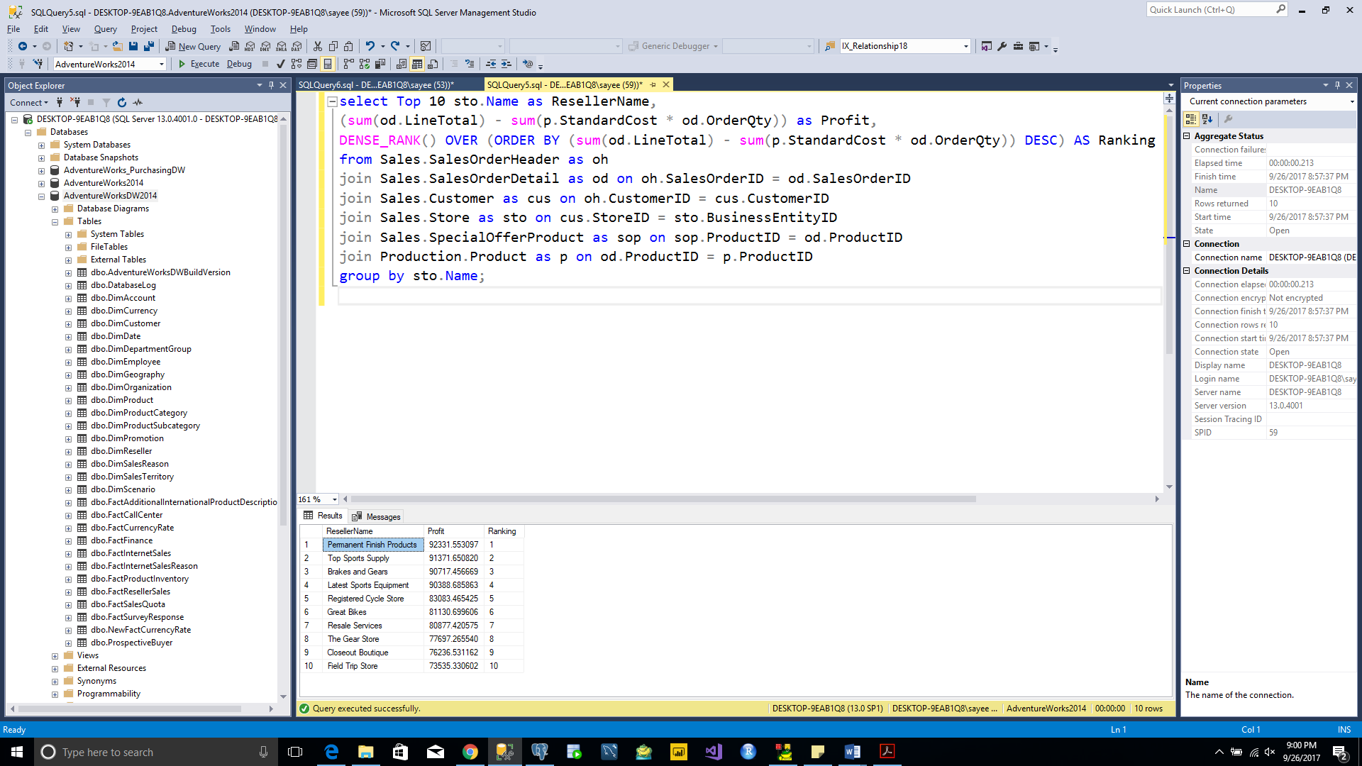

**Query 8**

* What are the top ten (internet) customers by profit?

select Top 10 concat(per.FirstName,' ',per.LastName) as OnlinePerson,

(sum(od.LineTotal) - sum(p.StandardCost * od.OrderQty)) as Profit,

DENSE_RANK() OVER (ORDER BY (sum(od.LineTotal) - sum(p.StandardCost * od.OrderQty)) DESC) AS Ranking

from Sales.SalesOrderHeader as oh

join Sales.SalesOrderDetail as od on oh.SalesOrderID = od.SalesOrderID

join Sales.Customer as cus on oh.CustomerID = cus.CustomerID

join Person.Person as per on cus.PersonID = per.BusinessEntityID

join Sales.SpecialOfferProduct as sop on sop.ProductID = od.ProductID

join Production.Product as p on od.ProductID = p.ProductID

group by concat(per.FirstName,' ',per.LastName);

TOTAL ROWS:-10 rows

TABLE USED:- SalesOrderHeader, SalesOrderDetail, SpecialOfferProduct, Product, Customer, Person

|  |  |
| --- | --- |
| INPUT COLUMNS | OUTPUT COLUMNS |
| per.FirstName | concat(per.FirstName,' ',per.LastName) as OnlinePerson |
| per.LastName |  |
| od.LineTotal | (sum(od.LineTotal) - sum(p.StandardCost * od.OrderQty)) as Profit, |
| p.StandardCost |  |
| od.OrderQty |  |
| od.LineTotal | DENSE_RANK() OVER (ORDER BY (sum(od.LineTotal) - sum(p.StandardCost * od.OrderQty)) DESC) AS Ranking |
| p.StandardCost |  |
| od.OrderQty |  |

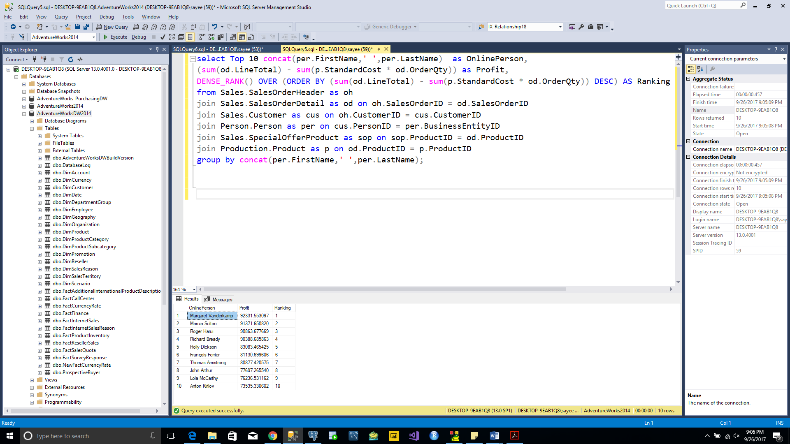

**Query 9**

* What are the total sales by country ranked (largest to smallest)?

select cr.Name as CountryName,

sum(od.LineTotal) as 'Total Sales',

DENSE_RANK() OVER (ORDER BY sum(od.LineTotal) DESC) AS Ranking

from Sales.SalesOrderHeader as oh

join Sales.SalesOrderDetail as od on oh.SalesOrderID = od.SalesOrderID

join Person.Address as ad on oh.BillToAddressID = ad.AddressID

join Person.StateProvince as stp on ad.StateProvinceID = stp.StateProvinceID

join Person.CountryRegion as cr on stp.CountryRegionCode = cr.CountryRegionCode

group by cr.Name;

TOTAL ROWS:-6 rows

TABLE USED:- SalesOrderHeader, SalesOrderDetail, Address, StateProvince, CountryRegion

|  |  |
| --- | --- |
| INPUT COLUMNS | OUTPUT COLUMNS |
| cr.Name | cr.Name |
| od.LineTotal | sum(od.LineTotal) as 'Total Sales', |
| od.LineTotal | DENSE_RANK() OVER (ORDER BY sum(od.LineTotal) DESC) AS Ranking, |

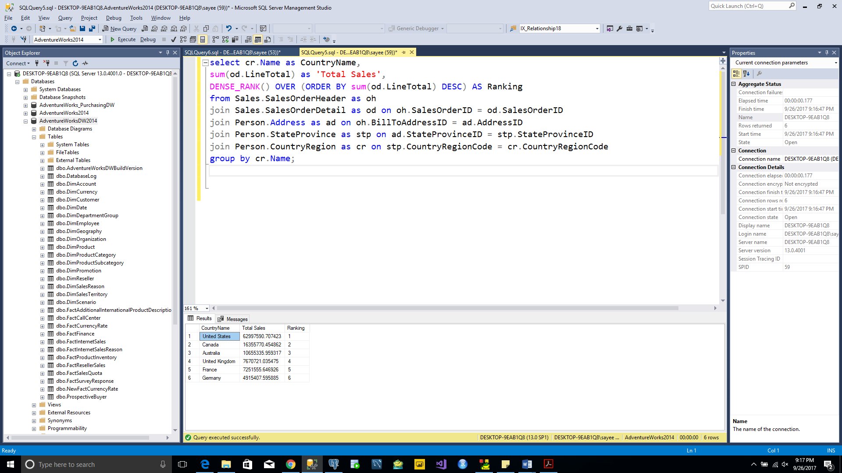

**Query 10**

* What are the products that are sold by a vendor (only available in AdventureWorks2014)

select ven.Name as VendorName, pr.Name as ProductName

from Production.Product as pr

join Purchasing.ProductVendor as prv on pr.ProductID = prv.ProductID

join Purchasing.Vendor as ven on prv.BusinessEntityID = ven.BusinessEntityID

group by ven.Name, pr.Name;

TOTAL ROWS:-460 rows

TABLE USED:- Product, ProductVendor, Vendor,

|  |  |
| --- | --- |
| INPUT COLUMNS | OUTPUT COLUMNS |
| ven.Name | ven.Name |
| pr.Name | pr.Name |

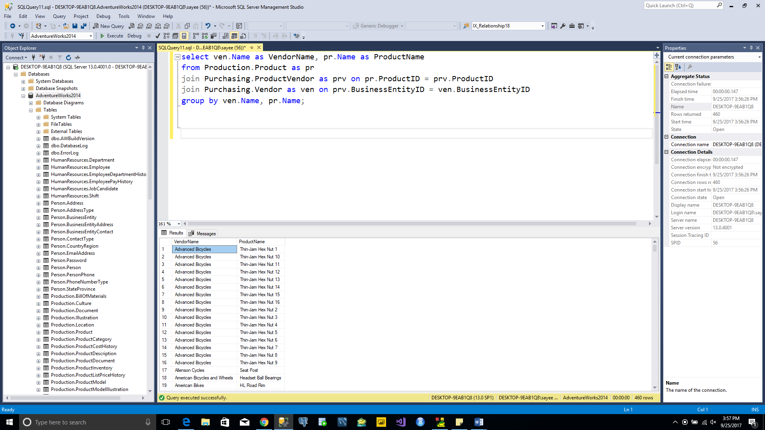

**Query 11**

* What are the total purchases (quantity & $ amount) by vendor by year (only available in AdventureWorks2014)

select format(poh.orderdate, 'yyyy') as Year, ven.Name as VendorName,

sum(pod.OrderQty) as TotalQuantity, sum(pod.LineTotal) as TotalPurchase

from Purchasing.PurchaseOrderHeader as poh

join Purchasing.PurchaseOrderDetail as pod on poh.PurchaseOrderID = pod.PurchaseOrderID

join Purchasing.Vendor as ven on poh.VendorID = ven.BusinessEntityID

group by format(poh.orderdate, 'yyyy'), ven.Name order by format(poh.orderdate, 'yyyy')

TOTAL ROWS:-275 rows

TABLE USED:- PurchaseOrderHeader, PurchaseOrderDetail, Vendor,

|  |  |
| --- | --- |
| INPUT COLUMNS | OUTPUT COLUMNS |
| poh.orderdate, | format(poh.orderdate, 'yyyy') as Year, |
| ven.Name | ven.Name |
| pod.OrderQty | sum(pod.OrderQty) as TotalQuantity |
| pod.LineTotal | sum(pod.LineTotal) as TotalPurchase |

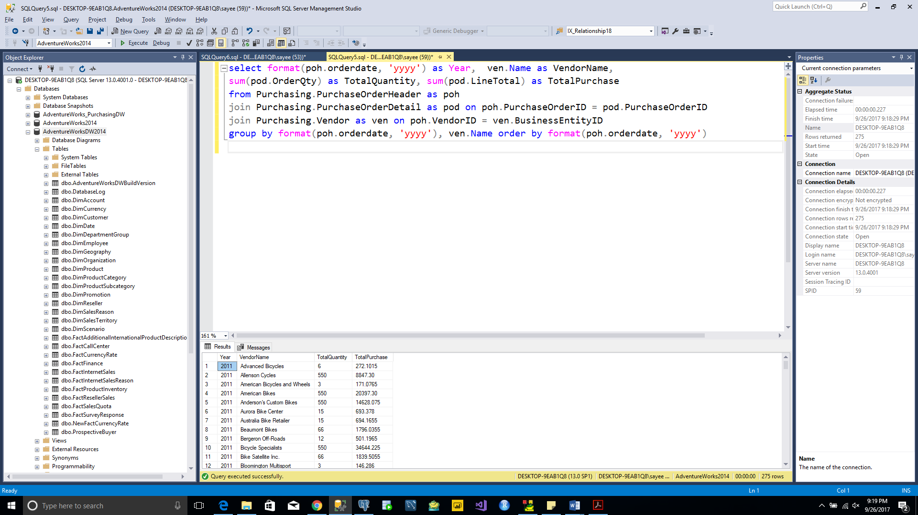

**Query 12**

* What are the total purchases (quantity & $ amount) by product name by year (only available in AdventureWorks2014)

select format(poh.orderdate, 'yyyy') as Year, pro.Name as ProductName,

sum(pod.OrderQty) as TotalQuantity, sum(pod.LineTotal) as TotalPurchase

from Purchasing.PurchaseOrderHeader as poh

join Purchasing.PurchaseOrderDetail as pod on poh.PurchaseOrderID = pod.PurchaseOrderID

join Production.Product as pro on pod.ProductID = pro.ProductID

group by format(poh.orderdate, 'yyyy'), pro.Name order by format(poh.orderdate, 'yyyy')

TOTAL ROWS:-742 rows

TABLE USED:- PurchaseOrderHeader, PurchaseOrderDetail, Product,

|  |  |
| --- | --- |
| INPUT COLUMNS | OUTPUT COLUMNS |
| poh.orderdate, | format(poh.orderdate, 'yyyy') as Year, |
| pro.Name | pro.Name |
| pod.OrderQty | sum(pod.OrderQty) as TotalQuantity |
| pod.LineTotal | sum(pod.LineTotal) as TotalPurchase |

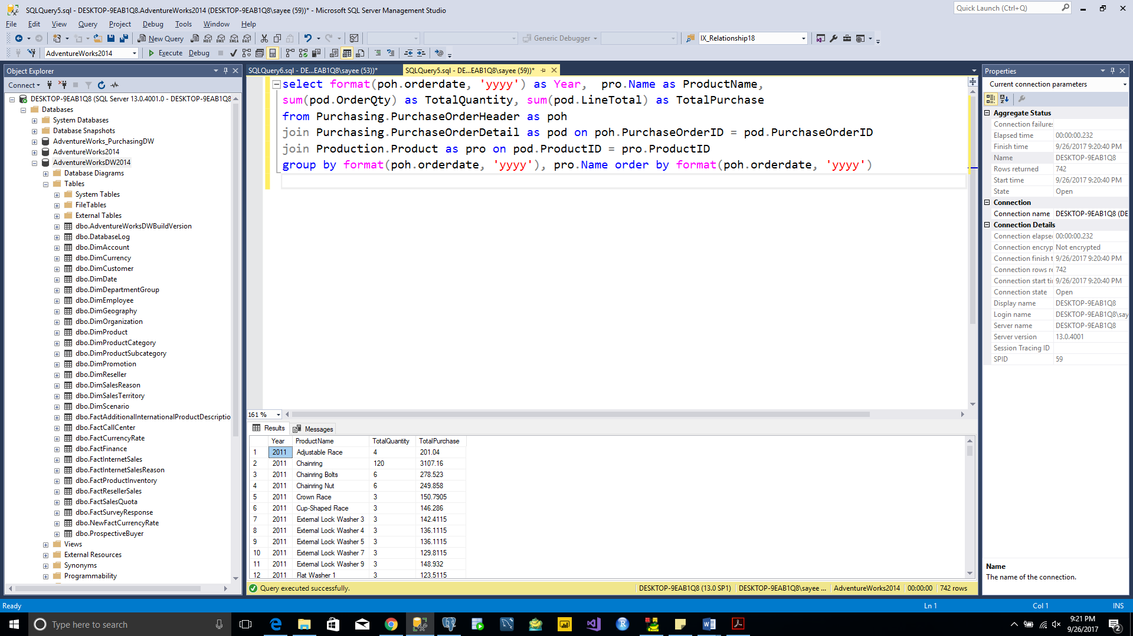

**Query 13**

* What are the total purchases (quantity & $ amount) by product hierarchy by year (only available in AdventureWorks2014)

select format(poh.orderdate, 'yyyy') as Year,

pc.Name as ProductCategory, ps.Name as ProductSubCategory, prd.Name as Product,

sum(pod.OrderQty) as TotalQuantity, sum(pod.LineTotal) as TotalPurchase

from Purchasing.PurchaseOrderHeader as poh

join Purchasing.PurchaseOrderDetail as pod on poh.PurchaseOrderID = pod.PurchaseOrderID

join Production.Product as prd on pod.ProductID = prd.ProductID

join Production.ProductSubcategory as ps on prd.ProductSubcategoryID = ps.ProductSubcategoryID

join Production.ProductCategory as pc on ps.ProductCategoryID = pc.ProductCategoryID

group by format(poh.orderdate, 'yyyy'), pc.Name, ps.Name, prd.Name

order by format(poh.orderdate, 'yyyy')

TOTAL ROWS:-150 rows

TABLE USED:- PurchaseOrderHeader, PurchaseOrderDetail, Product, ProductSubcategory, ProductCategory

|  |  |
| --- | --- |
| INPUT COLUMNS | OUTPUT COLUMNS |
| poh.orderdate, | format(poh.orderdate, 'yyyy') as Year, |
| pc.Name | pc.Name |
| ps.Name | ps.Name |
| prd.Name | prd.Name |
| pod.OrderQty | sum(pod.OrderQty) as TotalQuantity |
| pod.LineTotal | sum(pod.LineTotal) as TotalPurchase |

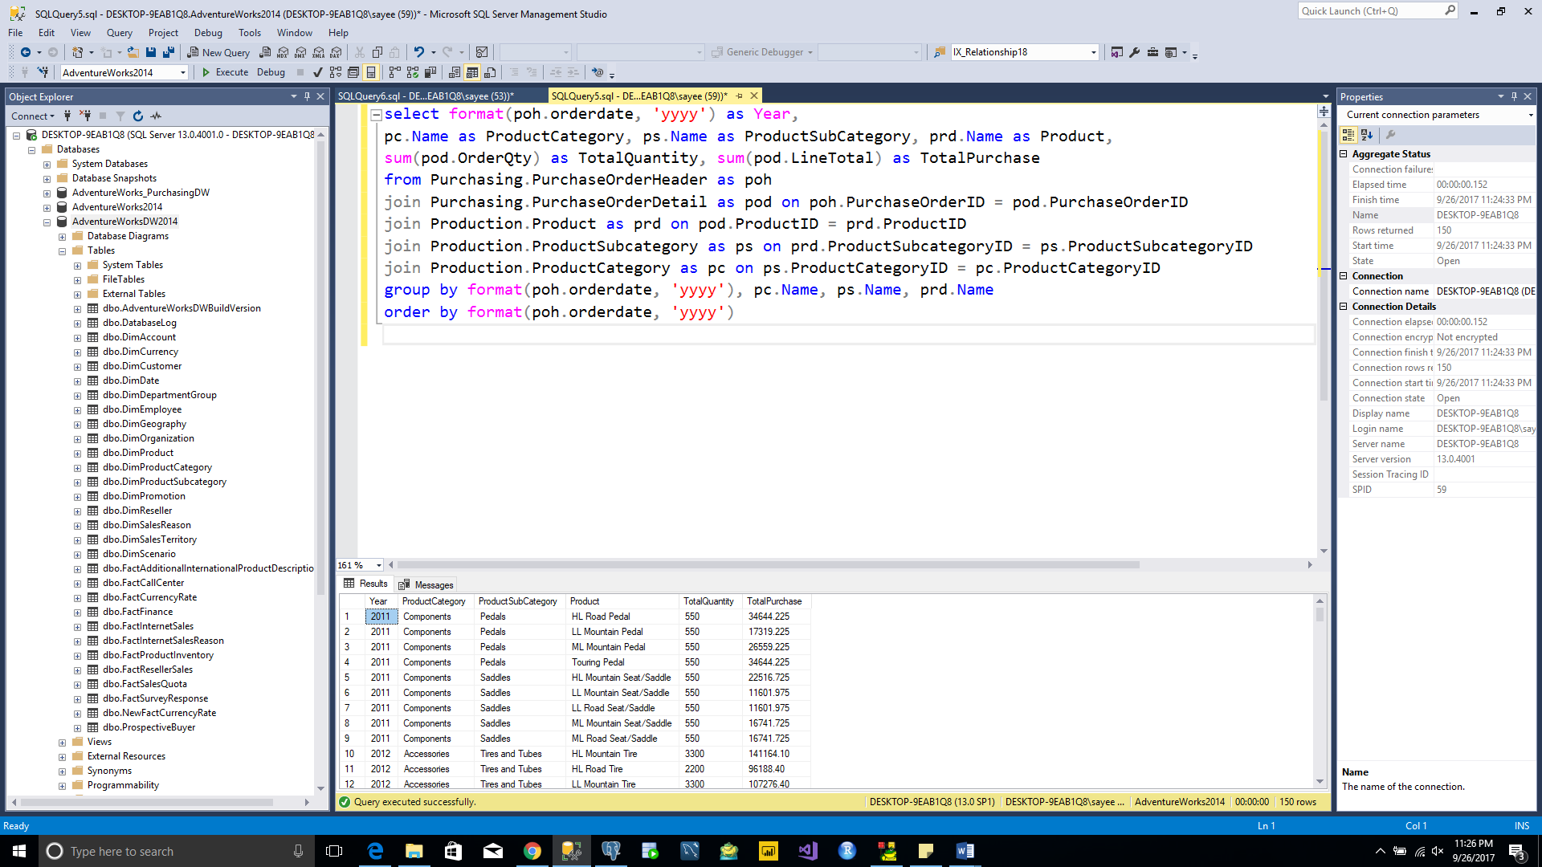

**Query 14**

Ranked order of products purchased by amount $ (only available in AdventureWorks2014)

* 1. By category

select pc.Name as ProductCategory, sum(pod.Linetotal) as TotalPurchase,

DENSE_RANK() OVER (ORDER BY sum(pod.Linetotal) DESC) AS Ranking

from

Purchasing.PurchaseOrderHeader as poh

join Purchasing.PurchaseOrderDetail as pod on poh.PurchaseOrderID = pod.PurchaseOrderID

join Production.Product as prd on pod.ProductID = prd.ProductID

join Production.ProductSubcategory as ps on prd.ProductSubcategoryID = ps.ProductSubcategoryID

join Production.ProductCategory as pc on ps.ProductCategoryID = pc.ProductCategoryID

group by pc.Name;

TOTAL ROWS:-3 rows

TABLE USED:- PurchaseOrderHeader, PurchaseOrderDetail, Product, ProductSubcategory, ProductCategory

|  |  |
| --- | --- |
| INPUT COLUMNS | OUTPUT COLUMNS |
| pc.Name | pc.Name |
| pod.LineTotal | sum(pod.LineTotal) as TotalPurchase |
| pod.Linetotal | DENSE_RANK() OVER (ORDER BY sum(pod.Linetotal) DESC) AS Ranking |

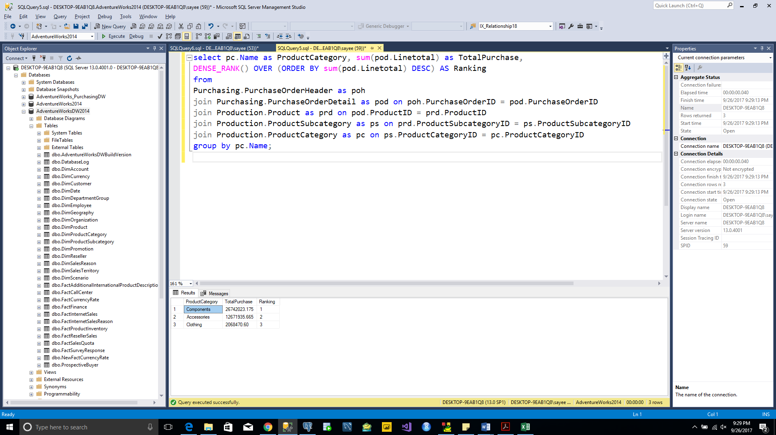

* 1. By subcategory

select ps.Name as ProductSubCategory, sum(pod.LineTotal) as TotalPurchase,

DENSE_RANK() OVER (ORDER BY sum(pod.LineTotal) DESC) AS Ranking

from Purchasing.PurchaseOrderHeader as poh

join Purchasing.PurchaseOrderDetail as pod on poh.PurchaseOrderID = pod.PurchaseOrderID

join Production.Product as prd on pod.ProductID = prd.ProductID

join Production.ProductSubcategory as ps on prd.ProductSubcategoryID = ps.ProductSubcategoryID

group by ps.Name;

TOTAL ROWS:-24 rows

TABLE USED:- PurchaseOrderHeader, PurchaseOrderDetail, Product, ProductSubcategory,

|  |  |
| --- | --- |
| INPUT COLUMNS | OUTPUT COLUMNS |
| ps.Name | ps.Name |
| pod.LineTotal | sum(pod.LineTotal) as TotalPurchase |
| pod.Linetotal | DENSE_RANK() OVER (ORDER BY sum(pod.Linetotal) DESC) AS Ranking |

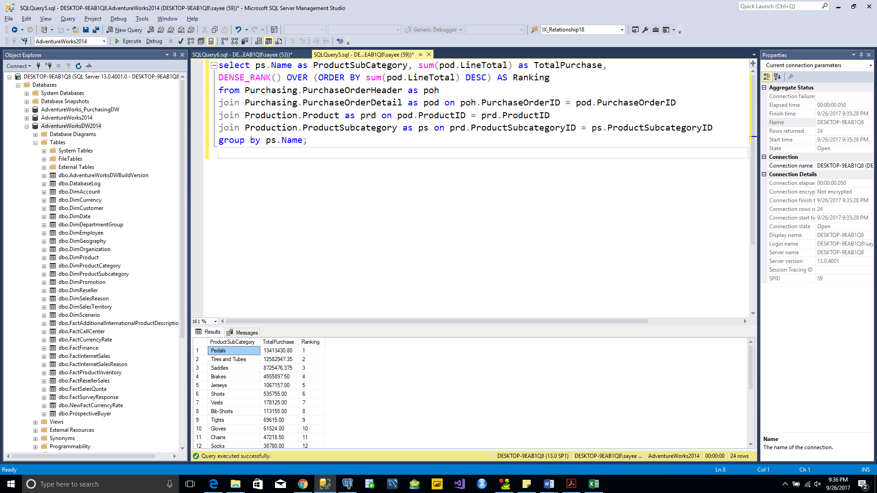

* 1. By product model (top 20)

select Top 20 pm.Name as ProductModel, sum(pod.linetotal) as TotalPurchase,

DENSE_RANK() OVER (ORDER BY sum(pod.linetotal) DESC) AS Ranking

from Purchasing.PurchaseOrderHeader as poh

join Purchasing.PurchaseOrderDetail as pod on poh.PurchaseOrderID = pod.PurchaseOrderID

join Production.Product as prd on pod.ProductID = prd.ProductID

join Production.ProductModel pm on prd.ProductModelID = pm.ProductModelID

group by pm.Name;

TOTAL ROWS:-20 rows

TABLE USED:- PurchaseOrderHeader, PurchaseOrderDetail, Product, ProductModel

|  |  |
| --- | --- |
| INPUT COLUMNS | OUTPUT COLUMNS |
| pm.Name | pm.Name |
| pod.LineTotal | sum(pod.LineTotal) as TotalPurchase |
| pod.Linetotal | DENSE_RANK() OVER (ORDER BY sum(pod.Linetotal) DESC) AS Ranking |

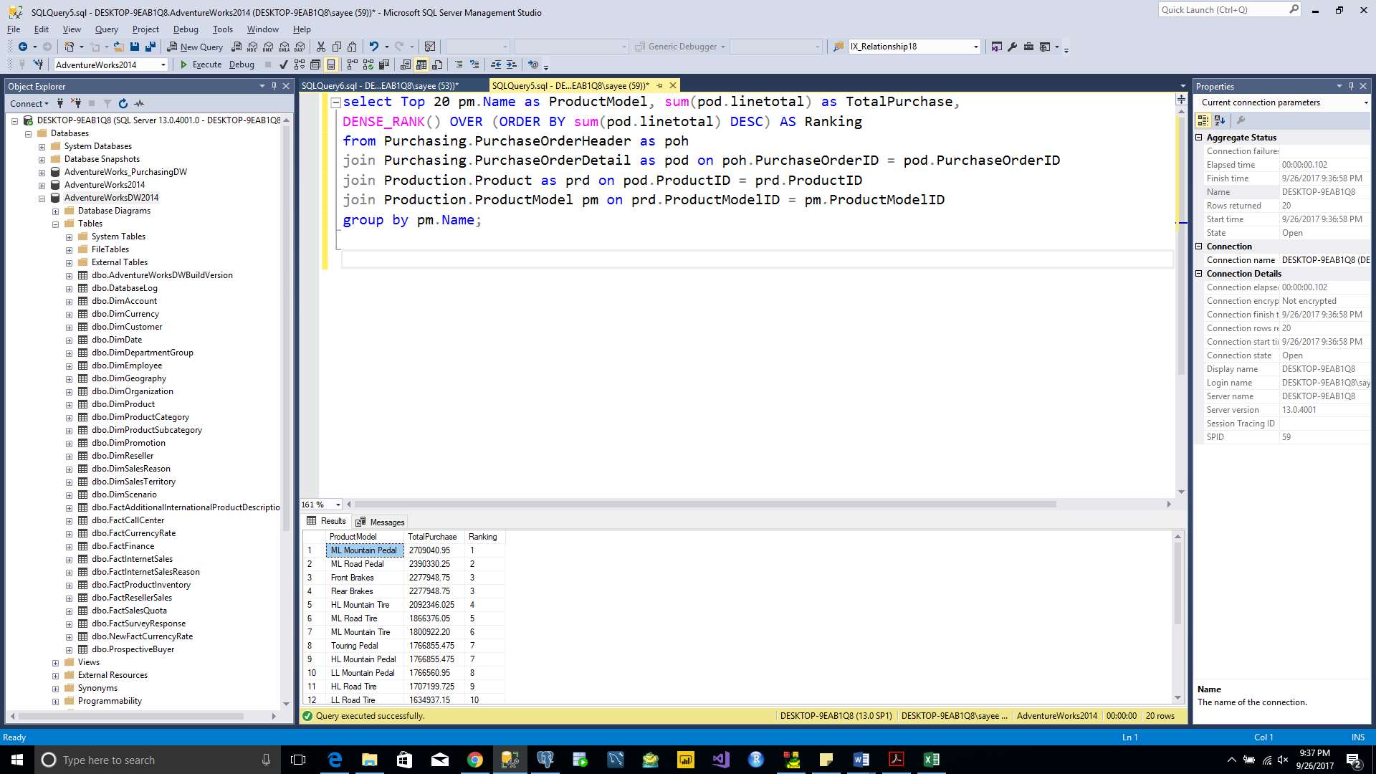

* 1. By product (top 20)

select Top 20 prd.Name as Product, sum(pod.linetotal) as TotalPurchase,

DENSE_RANK() OVER (ORDER BY sum(pod.linetotal) DESC) AS Ranking from

Purchasing.PurchaseOrderHeader as poh

join Purchasing.PurchaseOrderDetail as pod on poh.PurchaseOrderID = pod.PurchaseOrderID

join Production.Product as prd on pod.ProductID = prd.ProductID

group by prd.Name;

TOTAL ROWS:-20 rows

TABLE USED:- PurchaseOrderHeader, PurchaseOrderDetail, Product

|  |  |
| --- | --- |
| INPUT COLUMNS | OUTPUT COLUMNS |
| prd.Name | prd.Name |
| pod.LineTotal | sum(pod.LineTotal) as TotalPurchase |
| pod.Linetotal | DENSE_RANK() OVER (ORDER BY sum(pod.Linetotal) DESC) AS Ranking |

